HOW TO EXPORT A METHOD TO A PKG FILE
- Open the method Editor.
- Open the method to be exported.
- On the top toolbar go to File and scroll down to Export.
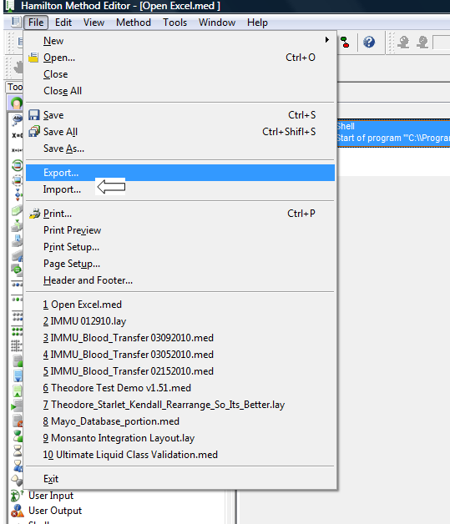
Click on the box on the right to browse to the location at which you want to store the package. By default the path will be the location of the method.

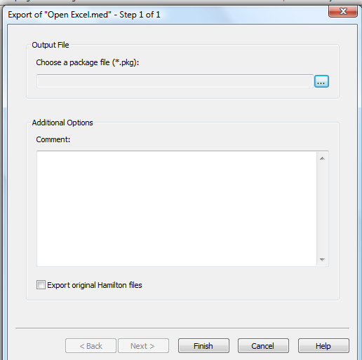

- Give the PKG file a name.
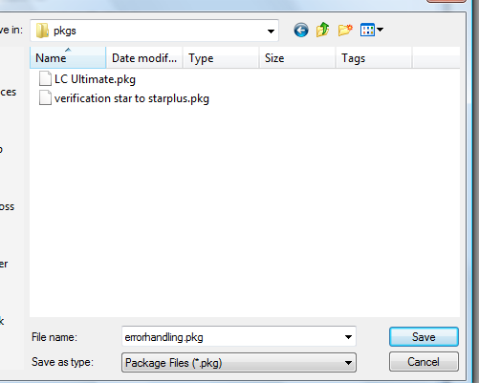
- Click on Save
- Click on Finish, the method will be packaged.
- See below for final window indicating it is finished and click on close.

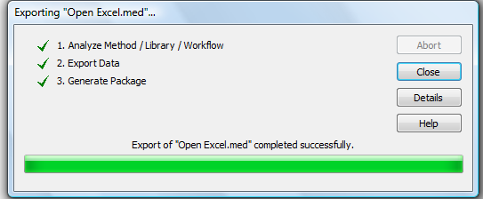
- Browse with Explorer to find your pkg file.

HOW TO IMPORT A PKG FILE.

- Take the package file (xxx.PKG) and put it in a known location.
- Open the method editor and go to the File command on the toolbar. Scroll down to IMPORT
- Click on the box as shown in the picture below to browse to the location of the pkg file.
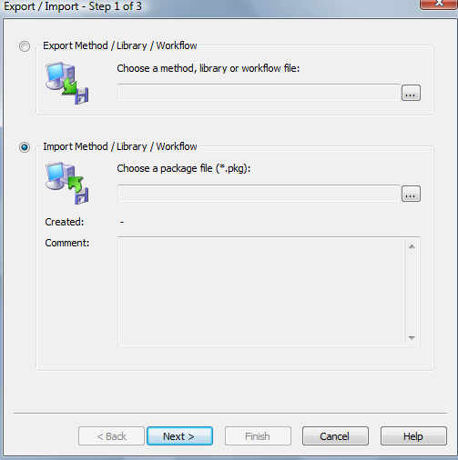
- Highlight the file, then click on open. And then Click on the “next” button at the bottom of the page.

- Go to the top of the window and select “Recovery”. Uncheck the box at the very bottom that says Import original Hamilton files.
“Recovery” will put your method files, labware, etc. in the same file structure as that of the exporting instrument.
If you would like method files, labware, and libraries to end up in default folders in the HAMILTON folder or you want to define your own folder locations or subfolders you can use one of the other options and an example follows below.
Don’t forget to uncheck the “Import original Hamilton files” box.
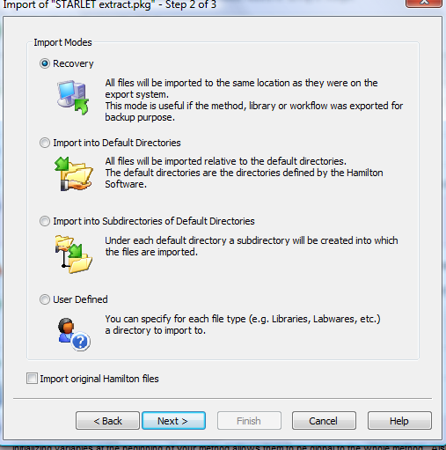
- Click on Finish.
- When the bar at the bottom window is fully green and it reads completed successfully, close the window.
****You also have the option of designating the specific path where the method will be imported.
Instead of Recovery, select “ user defined “ at the bottom of the window.
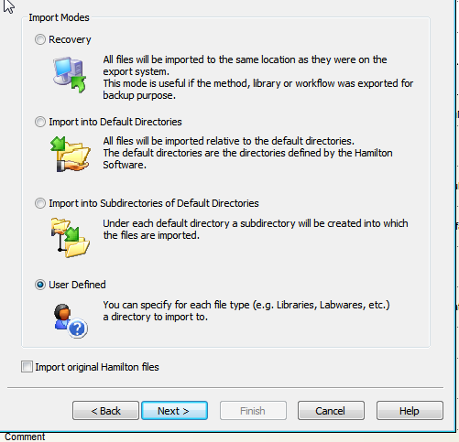
Then, click next.
The next window tab Methods/Workflow allows you to select the specific path by chosing “specified directory and browsing to the correct folder.
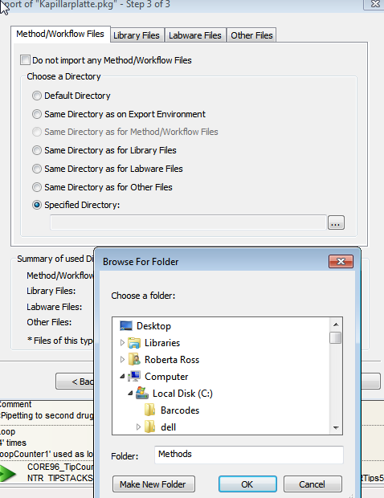

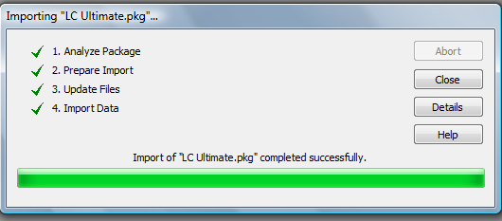
- You can now open your method by going to the File open command as normal and going to the path you imported the method into.
- You can check the log file to see where the method went if unsure. See example below.
MethPath: "C:\Program Files \HAMILTON\Demo\"

